Volunteers for Peace Vietnam (VPV)
Ho Chi Minh city Program
WORKCAMP 2020 (Jan-Jun)
CONTACT
General Contact:
Volunteers for Peace Vietnam (VPV), Ho Chi Minh office
Address: No.778/3 Nguyen Kiem Str, Ward 4, Phu Nhuan District, Ho Chi Minh City, Vietnam
Email: workcamp.south@vpv.vn & program@vpv.vn
Website: www.vpv.vn

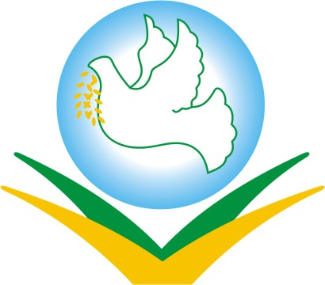

INTRODUCTION

Volunteers For Peace Vietnam (VPV) is a non-profit, voluntary organization founded in 2005 with the aim to promote voluntary service as a mean of cultural and educational exchange among people, for peace and friendship, and as an approach to address social problems.

VPV hosts international volunteers from different countries and places them in suitable projects depending on the interest of the volunteers and the needs of local communities. VPV also brings the opportunities for Vietnamese to join voluntary projects around the world. By joining our programs, volunteers will experience inter-cultural living and working environment and have a chance to help those in needs.

Over the past 15 years VPV has welcomed thousands of international volunteers from over 30 different countries. VPV is working in various locations in Vietnam, including Hanoi Capital and Ho Chi Minh City. VPV offers programs for individual volunteers and group volunteers, for duration from 1 week to 1 year. Our projects cover areas of education, social welfare, environment and community development, public health and medical support, cultural heritage preservation and youth action.

IMPORTANT INFORMATION

1. Insurance
VPV does not provide any kind of insurance. It is volunteers’ responsibility to buy insurance that covers the whole period of his/her stay in Vietnam.

2. Personal Transportation/Excursion
Each volunteer is responsible for arranging their transportation to/from the meeting point of the camp at their expenses. VPV does not cover transport, leisure activities or food outside of the project.

3. Application Requirements
VEF and copy of passport

4. Leader
VPV always has its own staff who coordinates the project from orientation until final evaluation. Besides that at most project, there are also some local volunteers who work alongside with international volunteers to make sure the group has good atmosphere and dynamic.

LIST OF WORKCAMPS (Jan-Jun 2020)

Camp code | Placement & Place | Date | Theme | Age | Number of volunteers
VPV-S2001R | Social Smile restaurant for low income people-Ho Chi Minh | 30.12.2019-06.01.2020 | SOCI/MAN | 18+ | 07
VPV-S2001E | Education camp for under-privileged students-Ho Chi Minh | 02.01-14.01.2020 | KIDS/YOUTH/EDU | 18+ | 07
VPV-S2001P | Ky Quang Pagoda -Ho Chi Minh | 06.01-18.01.2020 | KIDS/SOCI/MAN | 18+ | 07
VPV-S2001F | Happy organic farming- Ho Chi Minh | 13.01-20.01.2020 | ENV/MAN/EDU | 18+ | 07
VPV-S2002P | Ky Quang Pagoda -Ho Chi Minh | 03.02-15.02.2020 | KIDS/SOCI/MAN | 18+ | 07
VPV-S2002E | Education camp for under-privileged students-Ho Chi Minh | 10.02-23.02.2020 | KIDS/YOUTH/EDU | 18+ | 07
VPV-S2002F | Happy organic farming- Ho Chi Minh | 17.02-24.02.2020 | ENV/MAN/EDU | 18+ | 07
VPV-S2002P | Ky Quang Pagoda -Ho Chi Minh | 17.02-29.02.2020 | KIDS/SOCI/MAN | 18+ | 09
VPV-S2002R | Social Smile restaurant for low income people-Ho Chi Minh | 24.02-02.03.2020 | SOCI/MAN | 18+ | 07
VPV-S2002E | Education camp for under-privileged students-Ho Chi Minh | 24.02-08.03.2020 | KIDS/YOUTH/EDU | 18+ | 09
VPV-S2003F | Happy organic farming- Ho Chi Minh | 02.03-09.03.2020 | ENV/MAN/EDU | 18+ | 07
VPV-S2003E | Education camp for under-privileged students-Ho Chi Minh | 02.03-15.03.2020 | KIDS/YOUTH/EDU | 18+ | 09
VPV-S2003R | Social Smile restaurant for low income people-Ho Chi Minh | 09.03-16.03.2020 | SOCI/MAN | 18+ | 07
VPV-S2003P | Ky Quang Pagoda -Ho Chi Minh | 09.03-21.03.2020 | KIDS/SOCI/MAN | 18+ | 09
VPV-S2003F | Happy organic farming- Ho Chi Minh | 16.03-23.03.2020 | ENV/MAN/EDU | 18+ | 07
VPV-S2003E | Education camp for under-privileged students-Ho Chi Minh | 16.03-29.03.2020 | KIDS/YOUTH/EDU | 18+ | 09
VPV-S2003R | Social Smile restaurant for low income people-Ho Chi Minh | 23.03-30.03.2020 | SOCI/MAN | 18+ | 07
VPV-S2003P | Ky Quang Pagoda -Ho Chi Minh | 23.03-04.04.2020 | KIDS/SOCI/MAN | 18+ | 09
VPV-S2003F | Happy organic farming- Ho Chi Minh | 30.03-06.04.2020 | ENV/MAN/EDU | 18+ | 07
VPV-S2004E | Education camp for under-privileged students-Ho Chi Minh | 06.04-19.03.2020 | KIDS/YOUTH/EDU | 18+ | 07
VPV-S2004R | Social Smile restaurant for low income people-Ho Chi Minh | 13.04-20.04.2020 | SOCI/MAN | 18+ | 07
VPV-S2004P | Ky Quang Pagoda -Ho Chi Minh | 20.04-02.05.2020 | KIDS/SOCI/MAN | 18+ | 07
VPV-S2004F | Happy organic farming- Ho Chi Minh | 29.04-06.05.2020 | ENV/MAN/EDU | 18+ | 07
VPV-S2005P | Ky Quang Pagoda -Ho Chi Minh | 04.05-16.05.2020 | KIDS/SOCI/MAN | 18+ | 07
VPV-S2005R | Social Smile restaurant for low income people-Ho Chi Minh | 11.05-18.05.2020 | SOCI/MAN | 18+ | 07
VPV-S2005E | Education camp for under-privileged students-Ho Chi Minh | 18.05-31.05.2020 | KIDS/YOUTH/EDU | 18+ | 07
VPV-S2005F | Happy organic farming- Ho Chi Minh | 25.05-01.06.2020 | ENV/MAN/EDU | 18+ | 07
VPV-S2006P | Ky Quang Pagoda -Ho Chi Minh | 01.06-13.06.2020 | KIDS/SOCI/MAN | 18+ | 07
VPV-S2006R | Social Smile restaurant for low income people-Ho Chi Minh | 08.06-15.06.2020 | SOCI/MAN | 18+ | 07
VPV-S2006E | Education camp for under-privileged students-Ho Chi Minh | 15.06-28.06.2020 | KIDS/YOUTH/EDU | 18+ | 07
VPV-S2006F | Happy organic farming- Ho Chi Minh | 22.06-29.06.2020 | ENV/MAN/EDU | 18+ | 07

Projects description

Education/Teaching camp for under-privileged students
On the changing of society & economic in Vietnam in the past recently years, knowing one foreign language is an advance to find a job opportunity. For many under-privileged students, the chance to improve a foreign language, especially with a native teacher from that language is really difficult and rarely. The aim of the project is to help under-privileged students & children IN HO CHI MINH city a chance to improve foreigner language speaking & listening skill and to develop their communication skill on that language. There are 6 languages offered on the project: English, French, German, Japanese, Chinese & Korean. All courses are free.
The local students after joining that project will have more opportunity to find a better job, while children improving their foreign language background. 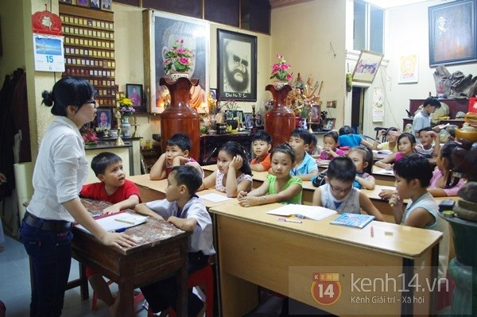

The participants through this project will also have chance to exchange culture with local student/children and understand the challenges on the life of children/students in Vietnam.
The language center was established in 2010 by sir Thich Nhuan Tam, a monk from a local Buddhist pagoda in GoVap district, Ho Chi Minh city, in order to support young people and students who are under-privileged to have chance to learn foreign language properly. With his active dedication & contribution and many individual sponsors & volunteers, thousand of students & children have chance to learn a foreign langue for free.
There are 6 language classes: French, English, German, Korean, Japanese, Chinese (From Basic/Beginning to Advance). Center opens from 8 AM to 5 PM everyday. On Saturday and Sunday, there is a class for pupils (from 6 years old to 15 years old). 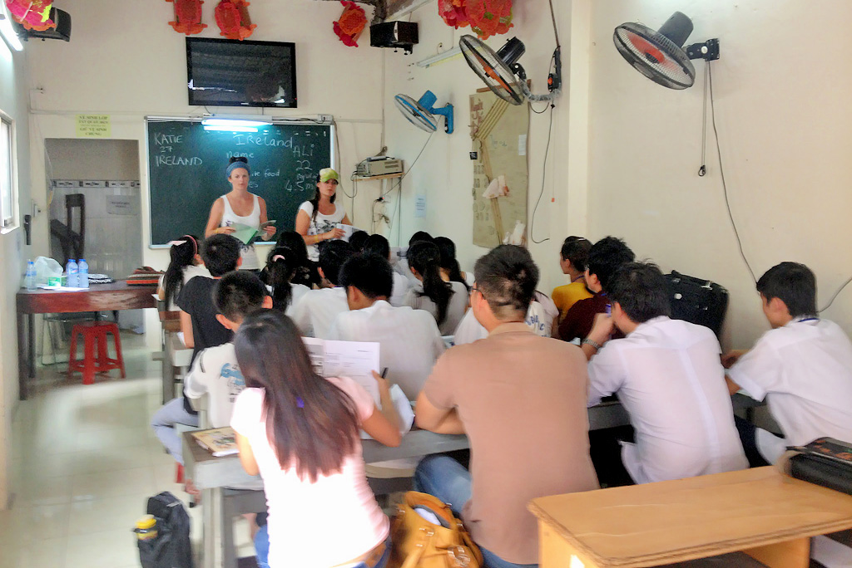
Teachers are international and local volunteer teachers.
At the moment, there are 50 volunteer teachers and about 1.000 students. After finishing course, most of students can find a good job.
Schedule: Volunteers will work from 9AM-3PM, 5 days per week. If they have schedule at week-end, they will have Mon & Tue free.

W: volunteers will spend time with the students and help to improve their language skill, organize games and other activities for them.
S: Youth and pupils in Vietnam
A: VPV’ Dormitory in Sai Gon. Shared rooms. Sleeping on bunk-bed with mattress. Showers and toilets are available. WIFI free at volunteer house. Breakfast and dinner will be prepared by volunteers. Lunch is provided at the project.
L: Go Vap district, Ho Chi Minh city (or Sai Gon- Southern part of Vietnam).
T: Tan Son Nhat airport (SGN), 20 minutes by taxi/bus to volunteer house
Q: interest and motivation working with youth & pupils.
LA: Vietnamese day, International day, self-organized city tour or excursions, etc.
PF: 250 USD or 230 EUR

Social welfare restaurant/ Social smile restaurant
Social welfare Restaurant was inaugurated in Oct 2012 by HCMC Charity Foundation in order to offer special meal with privileged price for low income students, immigrant & local workers in the area of HCMC. The foundation does fundraising to have enough budget, in order to be able to sell a quality meal with the cost of 2000 VND (about less than 10 USD cent).
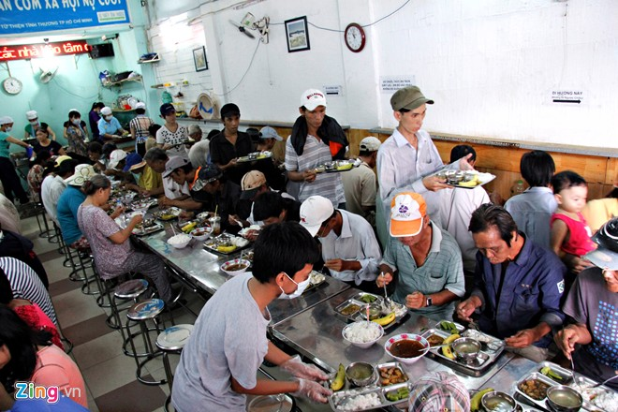
Volunteers will involve in project activities in order to make a good meals for poor people. If volunteer has experience on cooking, they can join for the cooking job. In the most cases, volunteers will help for preparing food, washing vegetables, set up the table and other works.
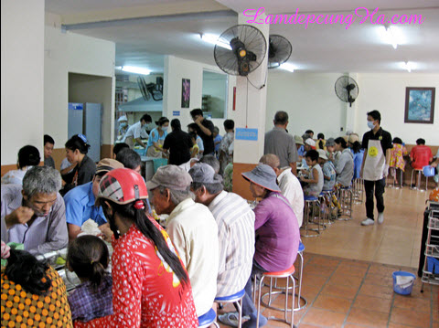
The restaurant located at the central of HCMC. The project also has some new project locations in the nearby are in central part of HCM. Volunteer will involve on a charity project and it help them to understand a part of the life in HCMC where the life is changing very fast and there is a big gap between people in the same city.
To get project, it takes about 30 minutes by bus from home.

-Volunteers must be 18 years old or more.
-Volunteers should have motivation to work on this project: Hard working, enthusiasm or pay attention.
-If volunteers has experience on cooking or was chef, they are very welcomed
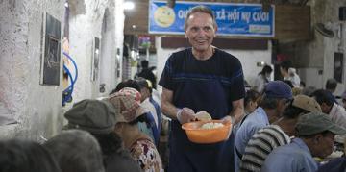
-Volunteers’ tasks are mainly helping project by preparing food, washing vegetables or set up table.
-When begin opening for buyers, volunteers’ tasks will be likely to bring dishes to eating table and serve.
-After finishing, volunteers would be cleaning the tables, washing dishes…
Working time: 7:30-13:30, from Monday to Friday
W: volunteers will work at restaurant to help for food preparation and serving at table to support poor students, immigrants & local manual workers.
S: Disadvantaged/poor people in Vietnam
A: VPV’ Dormitory in Sai Gon. Shared rooms. Sleeping on bunk-bed with mattress. Showers and toilets are available. WIFI free at volunteer house. Breakfast and dinner will be prepared by volunteers. Lunch is provided at the project.
L: City central, Ho Chi Minh city (or Sai Gon- Southern part of Vietnam).
T: Tan Son Nhat airport (SGN), 20 minutes by taxi/bus to volunteer house
Q: interest and motivation working so support people in difficult situation
LA: Vietnamese day, International day, self-organized city tour or excursions, etc.
PF: 250 USD or 230 EUR for 2 weeks/ 180 USD or 160 EUR for 1 week

Ky Quang Pagoda
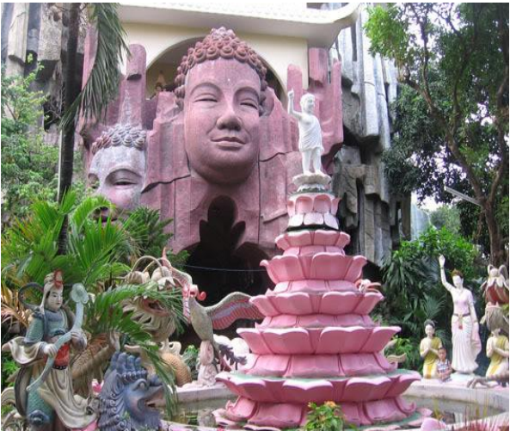

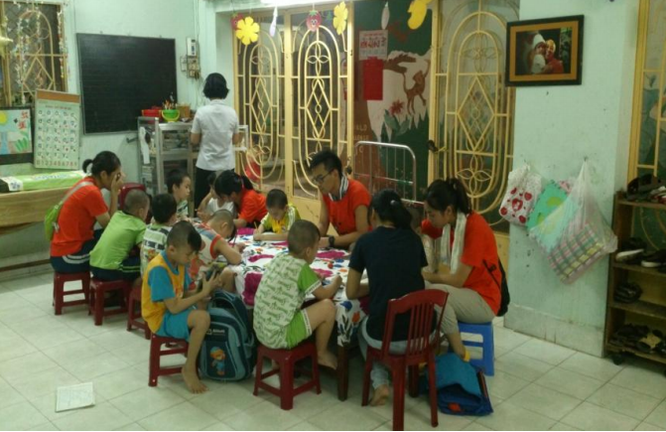
Ky Quang Pagoda was built in the early part of the 20th Century in 1924 and is quite famous in Ho Chi Minh City. The pagoda is now a place of charity for unlucky children and also helps treat diseases. Now, the pagoda is taking care and bringing up more than 100 children in the South of Vietnam. The children here have unfortunate backgrounds as many have been abandoned by their parents and relatives. Every few months, the monks find a new baby left in front of the pagoda gate. The head monk sometimes receives phone calls from hospitals requesting him to take in abandoned babies. At the moment, about 100 children are living in the Pagoda, their ages ranging from 5 days old to 40 years old. 60 of these are orphans/abbandoned that are suffering from cerebral-palsy, blindness or Down's syndrome.At present, about 30-40 local children have a chance to study for free at Ky Quang as some local teachers teach Vietnamese for them in the morning.
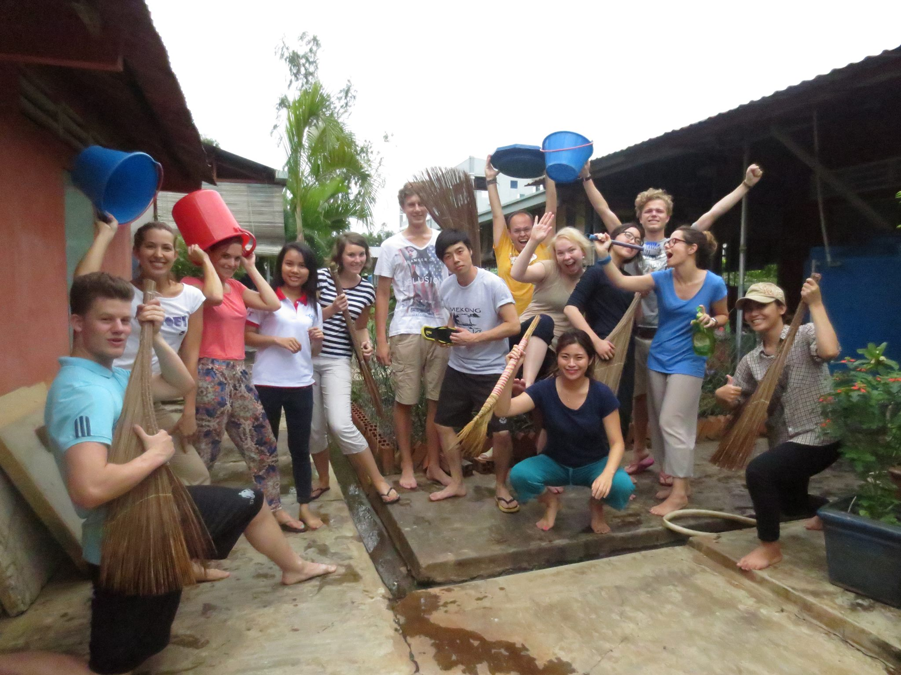
W: volunteers will spend time with the children and help to improve their English, organize games and other activities for them. Volunteers will also do some manual work such as cleaning, renovation, etc depend on the need of orphanage/pagoda. Volunteers will get closer to the children’s life and try to build up a wider horizon for the children and encourage them to learn better for the brighter future.
There are a possibility to support children with disability on the disabled children room.
S: Disadvantaged children in Vietnam
A: VPV’ Dormitory in Sai Gon. Shared rooms. Sleeping on bunk-bed with mattress. Showers and toilets are available. WIFI free at volunteer house. Breakfast and dinner will be prepared by volunteers. Lunch is provided at the project.
L: Go Vap district, Ho Chi Minh city (or Sai Gon- Southern part of Vietnam).
T: Tan Son Nhat airport (SGN), 20 minutes by taxi/bus to volunteer house
Q: interest and motivation working with children in difficult situation
LA: Self-organized city tour or excursions.
PF: 250 USD or 230 EUR

Happy Organic farming
The aim of the program is to provide Friendly environment for Volunteer and having the chance for cultural exchange with local people while learning about techniques to operate a professional organic farm.
Organic farming is a cultivation system based on the natural biological cycle of the ecosystem, biodiversity that suit climatic conditions and local soil, combined with traditional farming science and technology; without the usage of synthetic chemicals (such as plant protection products, growth regulators, chemical fertilizers …) in order to create products that are suitable to the benefit of people and the environment, protecting the well-being of man, land and ecosystems.
In order to bring healthy product to customer, the core members of this project has been working strenuously to reach their dream.
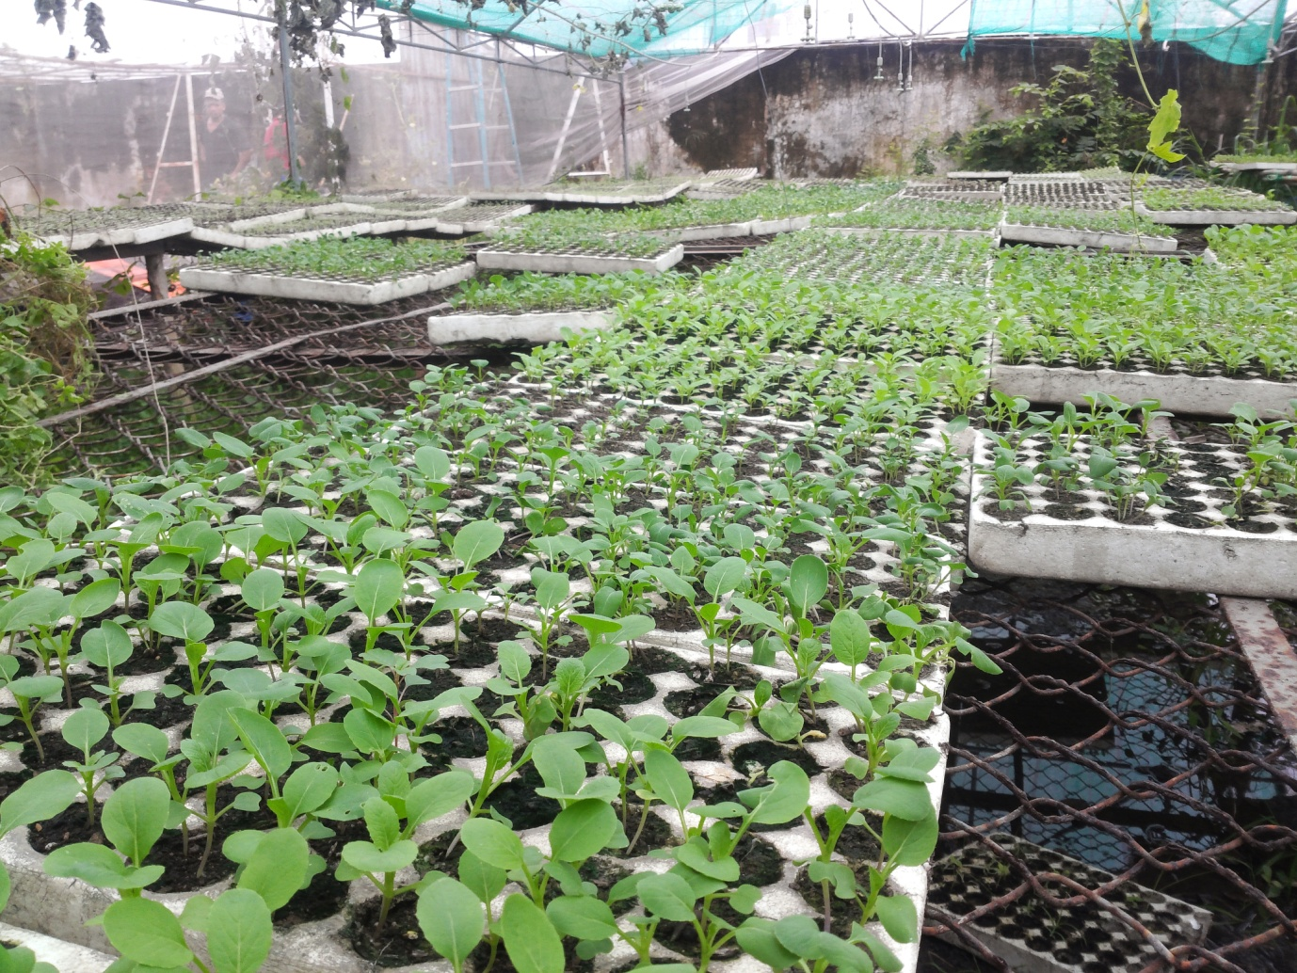
After 4 years of effort doing research, investment, and standardizing the process of growing vegetables organically, the current vegetable garden is now nearly 5000 m2, in out-skirt district of HCMC, has become reach a stable output of over 10 kinds of leaf vegetables and some kind of fruits.

The farm’s products are grown in natural harmony by re-balancing the ecological environment for cultivation of crops. Pest control by using natural traditional methods (which are empirically proven in the scientific assessment to be effective) and in particular, absolute compliance to the :6 NOs:
NO pesticides & herbicides
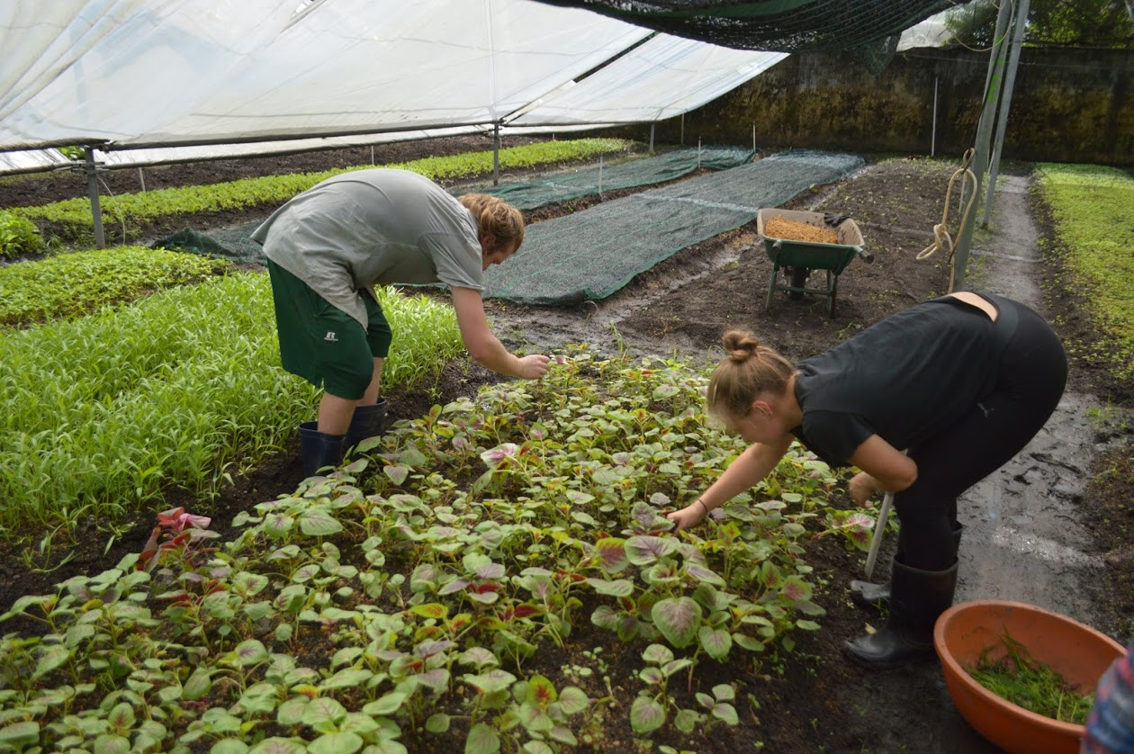
NO planting on soil and water contaminated with agricultural chemicals (*)
NO growth regulators
NO chemical fertilizers
NO of genetically modified seeds (GM seeds)
NO preservatives
In this farm, the worker use a high standard technology based on software to ensure about the quality and capacity of the products. The routine tasks on this farm:
1. Check plants regularly to find ecosystem pattern of the land
2. Field sanitation and plants healthy
3. Planning the seasonal crops
4. Use many species for intercropping, crop rotation as needed
5. Create environment for development of beneficial insects (predators)
6. Crops trap, pheromones trap
7. Measures for expelling insects (done synchronously and before the pests lay eggs)
8. Shielding vegetables in rows, or a greenhouse, membrane
9. Use resistant varieties
10. Apply insecticides of biological origin
Beside the main activities about farming, The owners of this farm also operate Education activities for children: On weekends, instead of going to the places of entertainment, parents can also add a fresh, educational attraction for children at Happy vegi’s organic garden. The children will have fun activities in the garden, learning about beneficial insects and harmful ones, how farmersplant and care for vegetables … With kindergartens, the children’s visit is a way to help them aquire more knowledge outside of books, helping them to understand the value of the product and the labor of the farmer.
In addition, children will learn through experiencing work of farmer themselves by taking care of a potted organic plant through the instruction given by us.
Volunteers must be 18 years old minimum. Volunteers must show eagerness, the ability to maintain motivation and reliability. Related to this, volunteers need to show assiduous attitude and initiative when working on the farm. Most importantly, volunteers need to be friendly and patient, making the good relationship with the local workers.
Volunteers will be responsible for completing tasks assigned by the manager of the farm. The general tasks would be:
- seeding the new vegetable on the farm
- spraying the farm with special kind of water
- weeding the un-useful weed.
- plan the soil to expand the farm, creating new vegetable beds
……
Moreover, the volunteers can have the chance to communicate with Vietnamese kids for showing the the works when they come for education about organic farm
Volunteers are also encouraged to try and establish new ideas for improving the quality of the product on this farm.
The timetable will be given on arrival with volunteers working 5 days per week. Working hours from 8:00am to 11:00am and 1:30pm to 4:00 pm, from Mon to Fri. Volunteers will work around 30 hours per week on the farm
S: Organic farming/ Agriculture/ Environment
A: VPV’ Dormitory in Sai Gon. Shared rooms. Sleeping on bunk-bed with mattress. Showers and toilets are available. WIFI free at volunteer house. Breakfast and dinner will be prepared by volunteers. Lunch is provided at the project.
L: Ho Chi Minh city (or Sai Gon- Southern part of Vietnam).
T: Tan Son Nhat airport (SGN), 20 minutes by taxi/bus to volunteer house
Q: interest and motivation working on agriculture & environment filed
LA:Self-organized city tour or excursions, etc.
PF: 250 USD or 230 EUR for 2 weeks; 180 USD or 160 EUR for 1 week.

